HOW TO ACCESS READ ALOUD

1. Click Review.

1. From the pop-up toolbar, click Read Aloud.

1. A screenshot of a computer

   AI-generated content may be incorrect.After Read Aloud icon appears, click it. This will trigger Read Aloud tools to appear on the right of your screen.

HOW TO CHANGE LANGUAGES

1. A screenshot of a computer

   AI-generated content may be incorrect.Click Review.
2. 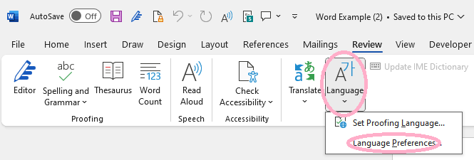Click Languages, then Language Preferences.
3. 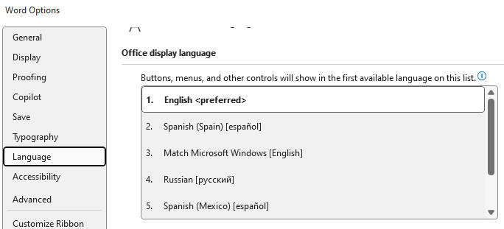Choose a Language.

Story 1  
Nabbed

"No thanks, no sweets!" said Doctor McNabb. "Not a slab, not even a dab. You see I am trying to lose some flab. Therefore, I eat just crab and I drink just Tab. Now please bring me my *bill*, or call it a tab if you *will*. But let's not confab, or in other words gab - for I must hasten back to my lab.”

​

As his waitress left to tally his tab, McNabb continued to blab, saying something about taking a stab, at not paying his tab.

​

Then he fled outside and quickly grabbed a cab. But thanks to the police he was soon nabbed, a criminal tabbed. From then on, his life was dreary and drab.